Memorial Chase Community Improvement Association (MCCIA) Area Map - 2014
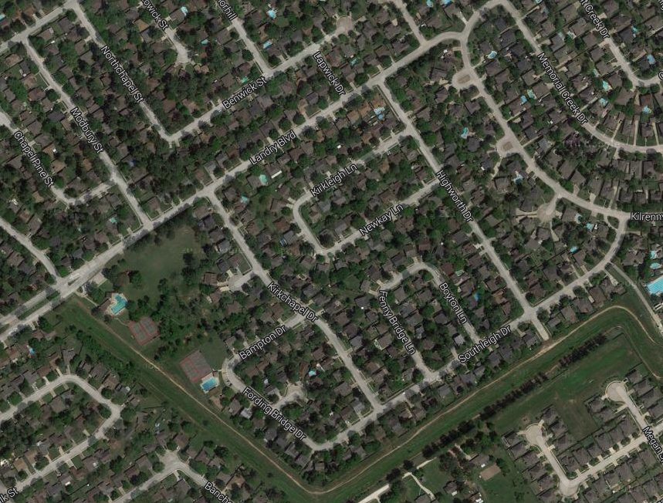
Link to map above: https://www.google.com/maps/@30.0193869,-95.558817,755m/data=!3m1!1e3

Memorial Chase Community Improvement Association (MCCIA) Area Map – 2014 (cont)
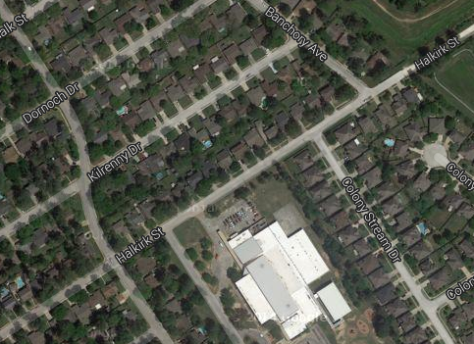
Link to map above: https://www.google.com/maps/@30.0152158,-95.5602225,378m/data=!3m1!1e3

